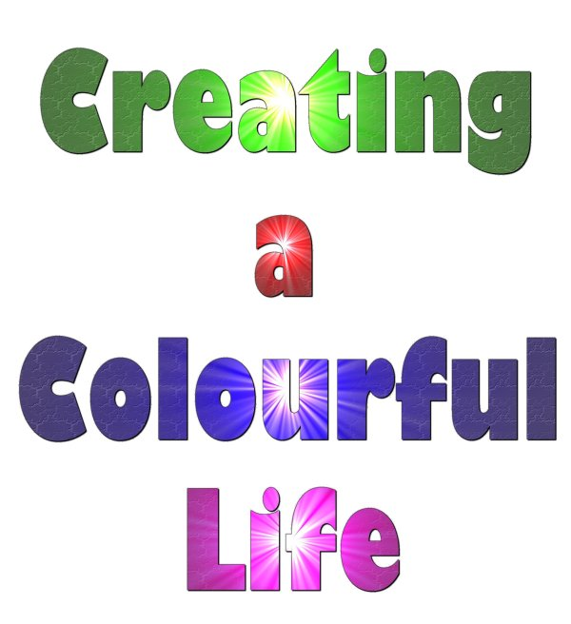

Professional Development in Science for KS2 Teachers




Creating a Colourful Life is a project aimed to raise the profile of Chemistry by using pigment science in schools and at Universities. The science of colour links to numerous aspects of the National Curriculum.

The objectives of the day are to:
- develop good subject knowledge in Science
- run through ideas for Science activities which meet National Curriculum requirements and use easy access equipment
- provide resources ready to use in the classroom

This booklet is designed to provide KS2 teachers with ideas and resources to teach some parts of the Science National Curriculum.

There are five different activities.

For each activity there is:

- a lesson planning sheet: this outlines the links to the National Curriculum with clear Learning Outcomes, provide some background information along with a lesson plan, a list of the resources required and the answers to the questions for the student worksheet.

- a “handout” worksheet. This contains the instructions for the pupils to follow and questions related to the subject.

This has been developed to be easy to fit into exiting schemes of work or project. It is intended to be easily modified and adapted to the users own needs.

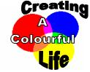
Smart Pigments Key stage 2 Lesson Planning

Scheme of work unit Light
National Curriculum link

Knowledge, skills and understanding Sc4 Physical processes

Seeing
Pupils should be taught that we see things only when light from them enters our eyes.
Learning outcomes
Describe the change in colours of a painted mug.
Explain how we are able to see the mug changing colour (students should understand that the light enters our eyes enabling us to see the mug; the change in colour is due to the heat; they will learn about light been absorbed and reflected in KS3).
Introduction notes
THERMOCHROMIC paint is a relatively recent development in the area of colour-changing pigments. After absorbing a certain amount of heat, the crystal or molecular structure of the pigment reversibly changes. It then absorbs and reflects light of a different wavelength (hence a different colour) than at lower temperatures.

Thermochromic paints are seen quite often as a coating on coffee mugs, whereby once hot coffee is poured into the mugs, the thermochromic paint absorbs the heat and becomes coloured or transparent, thus changing the appearance of the mug.

PHOTOCHROMISM is the change of colour due to light. This works by the molecules changing their chemical structure after absorbing UV light, usually from the sun.

Lesson Plan:

Starter
Demo heating up one mug to show change in colour. Discuss what happens (if you used a hairdryer you could discuss how we could test to see if it is the heat of the hair dryer or the blow of the hairdryer that causes the change in colour → could blow cold air and see no change).

Main Activity
Students paint pottery using thermochromic paint.

Plenary
Discuss other possible uses of this technology (see further work)

Could show pupils a bracelet made with photochomic beads (beads are white and become coloured in direct sunlight; should be kept in a draw to show effect if it’s a sunny day; a flash light may be necessary on a dull day)

Resources required:

- Bisque pottery (one per person) www.bisqueuk.com
- Thermochromic paint
- Paintbrushes
- Example mug
- Heat gun (hair dryer)

Health and Safety
This pottery is unglazed; it cannot be used for the consumption of food or drink.
A coat of varnish can be applied to improve durability of all items.

Further Work
Research other uses of thermochromic paints (example: used in hospital to check equipment has been sterilised) and other kinds of products which can change colour (example: sunglasses with photochromic lenses).

Answers:

- colour changes observed

- We see the colour change because the light from the pottery enters our eyes.
If the room was dark, the pottery would not reflect any light and we would not see it at all.
There is a colour change because of the heat but this doesn’t change the reason why the pottery can be seen.

Smart Pigments

Paint Your Own Pottery

You Will Need:
- unglazed bisque pottery
- photochromic paint
- paintbrushes

Instructions:

- Paint your pottery using the paintbrushes provided and your choice of paint and design.

- If you want to see your pottery change colour with heat, ask your teacher to heat it with a heat gun.

NOTE: This pottery is unglazed; it cannot be used for the consumption of food or drink.
A coat of varnish can be applied to improve durability of all items.

Questions

- Describe the change in colours of a painted mug.

………………………………………………………………………………………………

………………………………………………………………………………………………

………………………………………………………………………………………………

- Explain how we are able to see the mug changing colour.

………………………………………………………………………………………………

………………………………………………………………………………………………

…………………………………………………………..…………………………………..

CSI: Colours in ink Key stage 2 Lesson Planning

Scheme of work unit: Solids, liquids and how they can be separated

National Curriculum link

Knowledge, skills and understanding Sc3 Materials and their properties

Separating mixtures of materials
Pupils should be taught:
- that some solids dissolve in water to give solutions but some do not (Opportunity to discuss what would happen if ink was added to water)
- how to separate insoluble solids from liquids by filtering (Opportunity to discuss why it is not possible to use filtering to separate the ink from water)
- how to recover dissolved solids by evaporating the liquid from the solution
- to use knowledge of solids, liquids and gases to decide how mixtures might be separated.

Learning outcome:

Decide who could have committed the crime using the results of the investigation (separate out the colours in ink using chromatography).

Introduction notes:

- Chromatography is the collective term for a family of laboratory techniques for the separation of mixtures.
- Paper chromatography is an analytical technique for separating and identifying mixtures that are or can be coloured, especially pigments.
- The technique is based on a small concentrated spot of the sample being applied to a piece of chromatography paper about 1cm from the base.
- The paper is then dipped into a suitable solvent, such as ethanol or water.
- The solvent moves up the paper by capillary action. As the solvent rises through the paper it meets and dissolves the sample mixture, which will then travel up the paper with the solvent.
- Different compounds in the sample mixture travel at different rates due to the difference in solubility in the solvent, and are thus separated out on the paper.

Information:
- Washable pens are used in this activity because the pigments in the inks are soluble in water.
- Inks may appear to be a single colour, but are often composed of differently coloured pigments. Water can dissolve these pigments to effect a separation and produce a decorative pattern.
- The filter paper acts as a stationary phase on which the separation takes place, whereas the water acts as a mobile phase to carry the pigments through the filter paper.
- Although colours of different manufacturers may appear to be the same, often different pigments and different ratios of pigments are used to produce the same colour. Thus, it is possible to tell what type of pen was used.

Lesson Plan:

Starter
Add a few drops of ink to water. Discuss with the class what happens to the ink. Opportunity to reinforce key words (soluble/insoluble/dissolve/mixture). Could discuss how the ink could be separated from the water again.

Main Activity
Students use chromatography to separate the colours in the ink of two different pens and compare these to the pen used by the thief in order to identify who committed the offence.

Worksheet available with instructions and questions.

Plenary
Discuss answers to question 4 and what CSI teams have to consider to convict suspects (what other evidence could be used).

Discuss what is required in the experiment to make it work. Could we do the same experiment to separate the colours in nail varnish? (No, as nail varnish is not soluble/yes, but would have to use acetone or other nail varnish remover instead of water)

Discuss other uses of chromatography (examples of use of chromatography: used to see if a blood sample contains drugs/used to identify the amount of pollutant in a water sample)

Resources required:

- 3 sample containers
Containers should ideally be long and thin – we have successfully used sample vials.
- Plastic pipettes (optional: used to add small volume of water)
- Filter paper (Blotting paper can be used)
- Scissors and a pencil
- Water
- A Ransom note (labelled as Evidence No: 080)
- 2 different black pens (labelled as Evidence No: 081 & 082)
- Envelopes with the address “George Bloggs, 4 Anystreet, Anytown”, written on them using one of the pens. This is illustrated on the top of the next page.

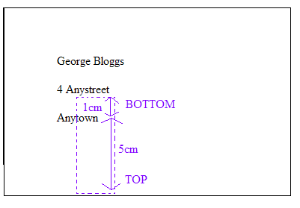
The area to be cut from the envelope needs to be of similar size to the filter paper.

The ink should be about 1cm from the bottom of the rectangular piece of paper and there should be plenty of paper above for the ink to travel up.

Labelling the top and bottom in pencil should avoid confusion.
Health and safety

Care must be taken if glassware is used.

Further Work

A similar practical investigate the colours in food dyes using chromatography.
Link to other separation techniques, such as separating out the pigments in leaves

Answers for worksheet:

1-3 As observed/depending on pens used
4. No. Pens are pretty common and so it is not definite that they committed the crime.

CSI: Colours in ink

Introduction

A crime has been committed and it is up to you to solve the mystery! At 17:00 hours, George Bloggs returned home to find that his CD player had been stolen. A ransom note (Evidence No: 080) had been posted through the door of his house, 4 Anystreet, Anytown, demanding a DVD for the safe return of his CD player.

George Bloggs suspected his best friend John Smith or brother, Tim Bloggs, may have been the thief. After a search of both suspects houses, two black pens were found which may have been used to write the address on the envelope (Evidence No: 081 from John Smith’s house and Evidence No: 082 from Tim Bloggs’ house).

By separating out the colours found in the black ink of the two pens, it is up to you to solve the crime. You have to match the pen found in the suspects’ houses with the one used to address the envelope. Can you solve the crime?

Practical

1. Add 1-2ml of water to each of the 3 sample containers
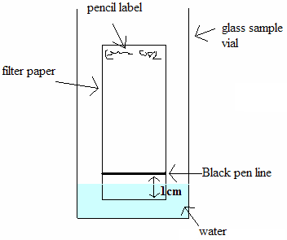
2. Label a piece of filter paper at the top in pencil with the evidence number; 081, and then a separate piece of filter paper with the evidence number 082.
3. Gently draw a horizontal line with the black evidence pen, 081 on the ‘081’ labelled filter paper, 2 cm from the bottom.
4. Do the same with evidence no. 082 on the ‘082’ labelled filter paper.
5. Carefully cut around the dotted pencil line on the envelope with the scissors.
6. Place both filter papers and the piece cut from the envelope upright into the vials, as shown in the diagram.
7. Wait at least 10 minutes and examine the colours.
Questions

1- What has happened on the filter paper?
………………………………………………………………………………………………………………………………………………………………………………………………………………………………………………………………
2- Do the colours produced by evidence 080 (the envelope) match the colours produced by one of the black pens 081 or 082?
……………………………………………………..…………………………………………………………………………………………………………………………………………………………………………………………………………
3- Which pen appears to have been used to write the address on the envelope?
………………………………………………..………………………………………………………………………………………………………………………………………………………………………………………………………………
4- Is the evidence conclusive enough to accuse the owner of the pen?
……………………………………………………………………………………………………………………………………………………………………………………………………………………………………………………………………………………………………………………………………………………

Food Dye Experiment Key stage 2 Lesson Planning

Scheme of work unit: Solids, liquids and Gas and how they can be separated

National Curriculum link

Knowledge, skills and understanding Sc3 Materials and their properties

Separating mixtures of materials
Pupils should be taught:
a) that some solids dissolve in water to give solutions but some do not (Opportunity to discuss what would happens if ink was added to water)
b) how to separate insoluble solids from liquids by filtering (Opportunity to discuss why it is not possible to used filtering to separate the ink from water)
c) how to recover dissolved solids by evaporating the liquid from the solution
d) to use knowledge of solids, liquids and gases to decide how mixtures might be separated.

Learning outcome:

Decide what could be the cause of hyperactivity using the results of the investigation (separating out colours within food dyes using chromatography).

Introduction notes:

- Chromatography is the collective term for a family of laboratory techniques for the separation of mixtures.
- Paper chromatography is an analytical technique for separating and identifying mixtures that are or can be coloured, especially pigments.
- The technique is based on a small concentrated spot of the sample being applied to a piece of chromatography paper about 1 cm from the base.
- The paper is then dipped into a suitable solvent, such as ethanol or water.
- The solvent moves up the paper by capillary action. As the solvent rises through the paper it meets and dissolves the sample mixture, which will then travel up the paper with the solvent.
- Different compounds in the sample mixture travel at different rates due to different solubility in the solvent, and are thus separated out on the paper.

Information:

- About 2.5% of children are sensitive to tartrazine.
- Additives are required to provide safe, appealing and convenient food all year round.
- Consumers often choose stronger and brighter colours made synthetically over natural colours, which in turn encourages more food manufacturers to use these colours.
- The E in E-numbers is short for European Communities. E numbers are issued after a large number of safety tests and expert scrutiny. All approved additives are given an E-number.
- E-numbers between 100-180 are colouring additives.
- Tartrazine should be avoided by asthmatics.
- Some E-numbers are naturally occurring vitamins required by everybody. E.g. E101 is vitamin B2.

Lesson Plan:

Starter
Add a few drops of ink to water. Discuss with the class what happens to the ink. Opportunity to reinforce key words (soluble/insoluble/dissolve/mixture). Could discuss how we could get the ink separated from the water again (evaporation).

Main Activity
Students use chromatography to separate the colours in different food dyes in order to identify what causes a boy to be hyperactive after he eats cake.

Worksheet available with instructions and questions.

Plenary
Discuss what is required in the experiment to make it work. Could we do the same experiment to separate the colours in nail varnish? (Students could give either answer as long as they argue their point of view. No, as the nail varnish is not soluble in water - would wash off when washing hands if it was/yes, but would have to use acetone or other nail varnish remover instead of water)

Discuss other uses of chromatography (examples of use of chromatography: used to see if a blood sample contains drugs/used to identify the amount of pollutant in a water sample).

Resources required

- 4 strips of filter paper (blotting paper if no filter paper available)
- 4 sample containers
Containers should ideally be long and thin – we have successfully used sample vials.
- Samples of red, green, blue and yellow food colouring (not natural)
- Pencil
- Water
- Plastic pipettes (optional: to add small quantity of water to the container)

Health and safety

Care if glassware is used

Further work

CSI investigation uses similar technique. Investigate colours in leaves (see website).

Answers for worksheet:

1. Paul is also sensitive to green food colouring (a mixture of yellow and blue).
Note: The yellow in the red food colouring is a different yellow.
2. Tatrazine.
Food Dye Experiment

Introduction

Paul was a lively kid. He enjoyed all the normal things that kids enjoy doing. However one day his mother, Mandy, noticed that whenever he ate fairy cakes with his favourite yellow coloured icing on top he was more lively than normal. She mentioned this to one of her friends, who said that some children are sensitive to some types of food. Yellow food colouring is known to cause some children to become hyperactive.

This made sense to Mandy, so she decided to avoid yellow food colouring. It was Paul’s birthday, and so to stop him becoming hyperactive when she made his birthday cake she decorated it with red, green and blue icing. However on his birthday Paul was still hyperactive after eating the cake.

Being a scientist, Mandy knew that colours could be mixed to make new colours. She decided to find out if yellow food colouring was used in other food colourings. This is the experiment she carried out. What results did she find?

Practical

- Place 1-2 ml of water into each of the 4 sample containers.
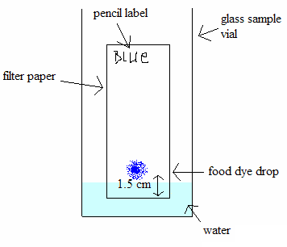
- Label each piece of filer paper at the top in pencil with the food colour to be tested.
- Use separate pipettes each time (to avoid contamination). Place one drop of food colour approximately 1.5cm from the bottom of each of the labelled filter papers
- Place each filter paper upright into a different vial as shown in the diagram.
- Wait at least 10 minutes and examine the colours.
Questions

1- Which other food colouring(s) is Paul sensitive to and how do you know?
……………………………………………………………………………………
……………………………………………………………………………………
……………………………………………………………………………………
2- Can you identify which substance Paul is sensitive to?
…………………………………………………………………………………………………………………………………………………………………………

Invisible Ink Key stage 2 Lesson Planning

Scheme of work unit: Solid Liquid Gas/Solubility

National Curriculum link

Knowledge, skills and understanding Sc3 Materials and their properties

Grouping and classifying materials
Recognise differences between solids, liquids and gases, in terms of ease of flow and maintenance of shape and volume.

Separating mixtures of materials
How to separate solid particles of different sizes by sieving (the solid bits of cabbage are insoluble so students can use sieving to obtain the solution of indicator)
Some solids dissolve in water to give solutions but some do not (in this case bicarbonate soda in warm water - opportunity to discuss the effect of temperature on solubility as bicarbonate soda will dissolve better in warm water than in cold water, also opportunity to discuss saturated solutions. The indicator solution can also be filtered to show that the chemical which gives the solution its colour is soluble)
How to separate insoluble solids from liquids by filtering
Use knowledge of solids, liquids and gases to decide how mixtures might be separated.

Learning outcome:

Identify the correct separation technique to use in different situations and explain this choice using scientific knowledge, whilst investigating the properties of invisible inks.

Introduction notes:

- Commonly acids and bases are used as invisible ink, and these are subsequently revealed by indicators.
- Indicators are chemical compounds which are different colours when in contact with either acids or bases.
- Indicators are also used in chemistry to show when chemical reactions are finished.
- An acid is traditionally considered any chemical compound that, when dissolved in water, gives a solution with a pH less than 7.0
- Common examples include acetic acid (in vinegar) and sulphuric acid (in car batteries).
- Generally acids have the following properties:
Taste: Acids generally have a sour taste.
Touch: Strong or concentrated acids often produce a stinging feeling.
Reactivity: Strong acids react aggressively with or corrode many metals.
Acids turn litmus paper (an indicator) red.
- Bases can be thought of as the chemical opposite of acids.
- A reaction between an acid and base is called neutralisation.
- Bases react with acids to produce water and salts (or their solutions).
- Generally bases have the following properties:
Taste: Bitter taste
Touch: Slimy or soapy feel on fingers
Reactivity: Caustic on organic matter, react violently with acidic substances
Bases turn litmus paper (an indicator) blue.
- pH is a measure of the acidity or alkalinity of a solution. Aqueous solutions at 25°C with a pH less than seven are considered acidic, while those with a pH greater than seven are considered basic (alkaline). pH 7.00 is considered neutral at 25°C.

Lesson Plan:

Starter
Discuss the equipment list as solid/liquid/gas and recall properties of these.
Contrast lemon/lemon juice. Discuss powders (could take the example of sand to compare) as solids.

Main Activity
Pupils prepare an acidic solution (lemon juice) and a alkaline solution (bicarbonate soda) and write an invisible message on filter paper with these two solutions.
They then prepare the indicator solution (with red cabbage) used to reveal the message.

Worksheet with practical procedure and questions to give out.

Extension:
Students could explain why they didn’t use filtering to separate the cabbage from the solution. Predict what would have happened if they did and explain why. If equipment is available, pupils can test if their prediction is correct.
Answer: They actually could have used filtering but it would take longer and require more equipment. If filtering was used, the same solution of indicator would be collected as the coloured chemical is soluble in the water.

Plenary
Could use the extension as a discussion point and reinforce key words: soluble, insoluble and dissolving.

Resources required:

- Diced red cabbage
- Lemon
- Bicarbonate of soda
- Warm water
- Pestle and Mortar (or similar)
- Sieve
- Paper
- Plastic cups or containers
- Paint brushes
- Filter paper and funnel (for possible plenary/extension)

Health and safety

Care needs to be taken to ensure the water is not too warm as to scold the pupils.

Further Work

Investigate the difference between pigments and dyes. Dyes will dissolve fully in solution whilst pigments will not. Explore how these properties make them useful for different purposes.
Investigate the use of other readily available materials as invisible inks. Explore which are acids and which are bases.

Answers for worksheet:

1. Indicators are chemical compounds which are different colours when in contact with either acids or bases.
2. Lemon Juice – acidic, bicarbonate of soda solution – alkaline
3. An ideal invisible ink should be easily made, hard to detect and easily and safely revealed. Invisible inks are normally non-greasy and not visible under UV light (a common screening method for post).
4. In addition to indicators, heat can also be used to reveal messages. A substance applied to the paper burns at a lower temperature than the paper and the message is revealed.

Invisible Ink Experiment

Introduction

Invisible inks are used to send secret messages. Secret messages are hidden within an ordinary letter, and can be revealed by the receiver. A secret message prevents other people from reading the message, or even knowing it is there. A secret message should be used with a believable normal message in order to hide the secret message (a blank piece of paper would be suspicious!).

Invisible inks can be used as a fun way to communicate secretly with friends. An ideal invisible ink should be easily made, hard to detect and easily and safely revealed. Invisible inks are normally non-greasy and not visible under ultra violet light (a common screening method for post).

Commonly acids and bases are used as invisible inks, and these are revealed by indicators. Indicators are chemical compounds which are different colours when in contact with either acids or bases. With acids, indicators generally turn red, and with bases they generally turn a blue/green colour.

In addition to indicators, heat can also be used to reveal messages. A substance applied to the paper that burns at a lower temperature than the paper and so the message is revealed.

In this practical you will investigate making up solutions and then using them to create your own secret messages!


Practical

- Squeeze some lemon juice into a container.
- In a different container dissolve some bicarbonate of soda with some warm water. Stir well – it does not matter if it is not completely dissolved.
- Use different brushes to apply both the lemon juice and bicarbonate of soda solution to separate pieces of paper. It is important that you allow both to dry thoroughly before you reveal your messages.
- Red cabbage contains a natural indicator which can be used to reveal messages. Mash the diced red cabbage and warm water in a pestle and mortar. Sieve the mixture. You should get a dark purple solution.
This will be your indicator.
- Apply your indicator over the top of the messages you originally created using a paintbrush.

Questions

1) What happened when you applied the indicator to your pictures?
…………………………………………………………………………………………………………………………………………………………………………
2) What is an indicator?
…………………………………………………………………………………………………………………………………………………………………………
3) Is the lemon juice acidic or basic? Is the bicarbonate solution acidic or basic?
……………………………………………………………………………………
4) What properties are required for a good invisible ink?
…………………………………………………………………………………………………………………………………………………………………………

Ancient Art Practical Key Stage 2 Lesson Planning

Scheme of work unit: Characteristics of materials
Rocks and soils

National Curriculum link:

Knowledge, skills and understanding Sc3 Materials and their properties

Grouping and classifying materials.

Pupils should be taught:

to describe and group rocks and soils on the basis of their characteristics, including appearance, texture and permeability (in this case the properties required to be able to use the rocks to make pigments could be discussed and contrasted with rocks which couldn’t be used for this purpose)

to recognise differences between solids, liquids and gases, in terms of ease of flow and maintenance of shape and volume.

Changing materials
Pupils should be taught:
- to describe changes that occur when materials are mixed
- that non-reversible changes result in the formation of new materials that may be useful (in this case the paint has new properties – although pigments are insoluble you cannot separate them from the binder again ie irreversible change)

Learning outcomes:

Rocks and soils:
State that underneath all surfaces is rock which we may not be able to see, rocks get broken down into pebbles and soils which we can often see, and that there are different sorts of rock with different characteristics. Pebbles and soils from different rocks consequently have different characteristics.

Particle model:
Describe how new materials can be formed and how their properties can be useful. Compare natural paint and modern paint in terms of colours, formation and uses. (link science knowledge and technology to the development of paint and how we can develop paint with particular properties to suit our use)

Information:

- Cave paintings have been found throughout the world, from dark limestone caves in the South of France to rock shelters in Zimbabwe.
- Cavemen had limited knowledge about pigments, and few tools with which to make them. So they used the minerals around them to obtain colours.
- They would grind the minerals to a fine powder, and then use saliva, ear wax or animal fat to make the paint stick to the surface.
- They used chewed twigs as brushes.
- By the time of the Ancient Egyptian era there were more colours available. These were made by heating natural materials.
- The Egyptians traded new brightly coloured minerals, such as Saffron. The Egyptians also developed better tools to grind them with.
- Egyptians found ways of extracting sap from plants, as well as using milk from cows to bind their pigments together to form paint.
- By Medieval times, people travelled and traded even more widely across Europe. A large variety of colours were now becoming available.

Suggested Lesson Plan:

Starter
Discuss with pupils how they think cavemen painted pictures on their cave walls. Invite them to give ideas about what they would use for paints, brushes etc. Compare and contrast the colours obtained naturally with the man-made pigments available today. Explore how a caveman might “lighten” the colours they were using.

→ Link to making new substances or to use of rocks and soils to share learning objectives depending on the unit studied

Main activity:
Pupils to compare paints made from natural materials and modern day paints with the samples provided.

Then pupils make their own paint and use it to paint a picture.
Worksheet with questions available.

Plenary:
Rocks and soils:
Discuss properties of rocks required to be used to paint. Cavemen would have had to use very hard rocks to grind others into fine powders (different hardness). Porous rocks tend to be less hard than non porous rocks. Different colours could be obtained by using different rocks but the range would have been limited. They would have used other natural pigments (plants for example) to make other colours.

Particle model:
Discuss differences in natural paint and modern paint in terms of colours, formation and uses.

Resources Required:

For detailed information about sourcing the materials please see our resources sheet. http://www.creatingacolourfullife.co.uk/download/resourcelist.pdf

For this experiment it is only necessary to have an example of a natural pigment and one of a man-made pigment.

- Natural pigment (Ancient): Iron Oxides (yellow, red)
Malachite
Chalk Rock
Ultramarine Blue
Chalk Sticks
- Man-Made pigment (Modern): Powder Paints
- PVA Glue
- Eggs (Optional)
- Pestle & Mortar (if grinding is required)
- Plastic Cups
- Spoons
- Paint Brushes
- Something to paint

Health and safety:

If using eggs as a binder, be sure there are no allergies towards them.
Care must be taken when grinding the ancient materials.

Further Work:

Pupils can make their own “cave chalk stick” using egg shells. Information about this is available on our website – www.creatingacolourfullife.co.uk under the experiments section. Relates to the concept that materials can be mixed together to form a new, usable item.

The ancient and modern paints that the children have made can be used to make a display, outlining what they have learned.

Answers worksheet:

- Minerals and rocks
- Spit, animal fat and/or ear wax.
- Browns, dark oranges, dark reds.
- Modern day paints are a lot brighter. Much wider selection of colours.
- Paint pigment: Dry, fine powder, not sticky, solid.
Binder: Very sticky, viscous, liquid.
- Sap from plants and milk from cows.
Ancient Art Practical

Introduction

Cave paintings have been found throughout the world. Cavemen had very few tools available to them, and they had to use the minerals and rocks around them to obtain colours. They would dig these minerals and rocks from the ground and then grind them into a fine powder.
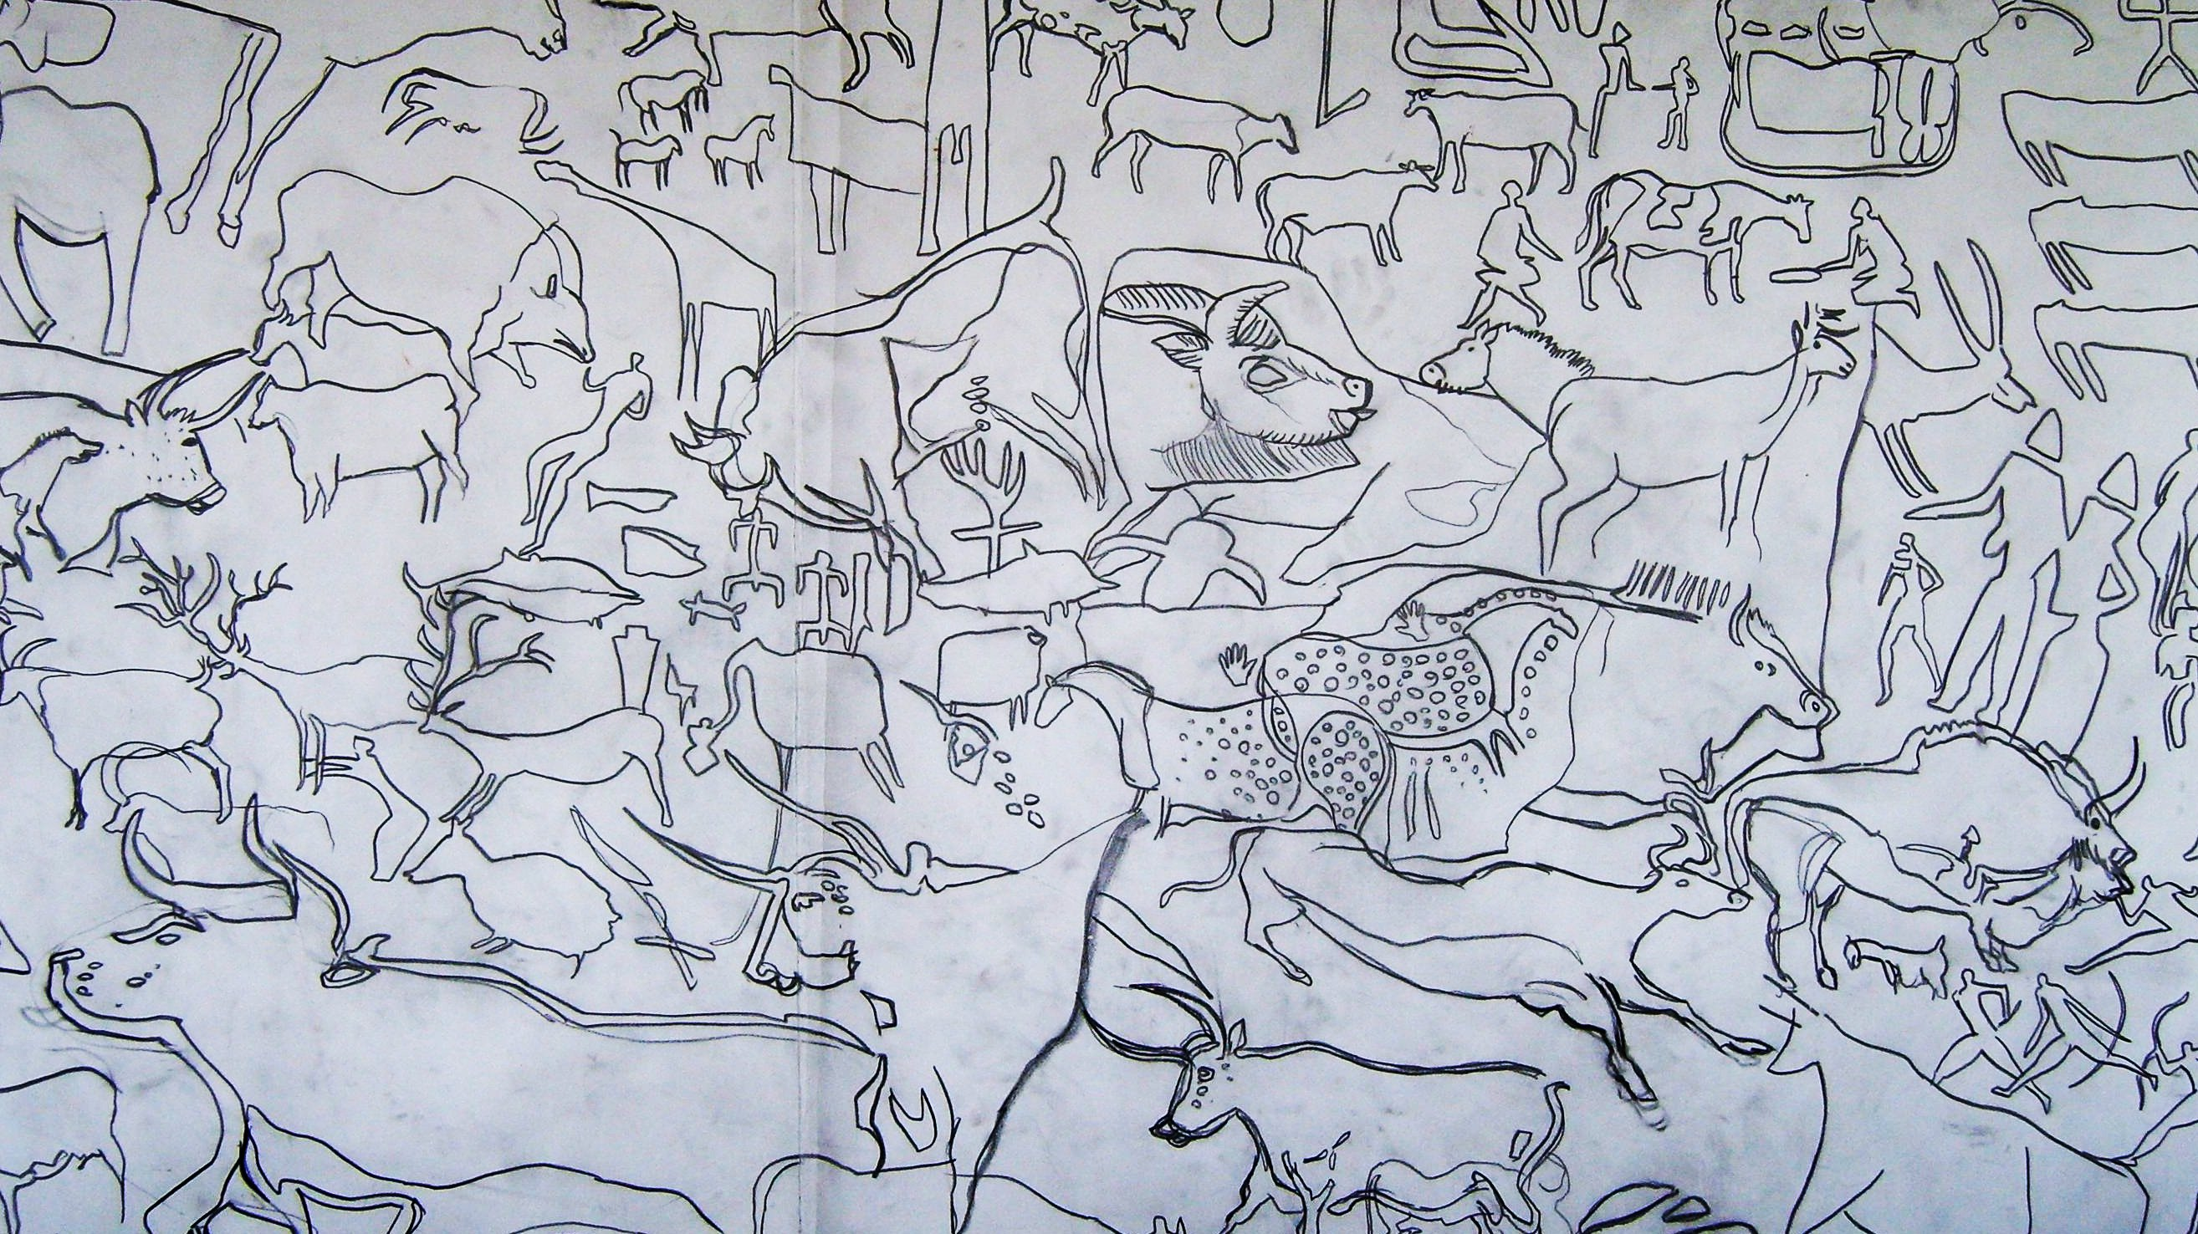

Modern cave art drawing.

The cavemen would use their spit, animal fat or ear wax to make their paints stick to the cave walls.

Cavemen would also use their fingers and the end of chewed twigs to paint their pictures.

By the time of the Ancient Egyptian era there were more colours available. They found new brightly coloured minerals, and better tools to grind them with.

Egyptians found ways of extracting sap from plants, as well as using milk from cows to bind their pigments together to form paint.

By Medieval times people travelled and traded even more widely across Europe. A large variety of colours were now becoming available.

In this practical you will pretend that you are a caveman, and use natural materials in order to paint pictures, just like the cavemen did. You will also paint pictures using modern day paints and compare the colours.

Practical:

- Look at both the natural pigments and the man made pigments. What are the differences between them? Which is your favourite pigment?
- Add a teaspoon of your favourite pigment to a plastic cup. If you are using a natural material, make sure it has been ground to a fine powder first.
- Add a few drops of water and mix with a brush until you have a smooth paste.
- Separate the egg yolk from the egg white and dispose of the egg white. Add the egg yolk to your plastic cup. (If you are using PVA glue, add 2 teaspoons of it to the plastic cup instead).
- Mix the egg yolk with your pigment paste using a paint brush.
- You are ready to paint.

Questions:

- What did the cavemen use to make their paints?

………………………………………………………………………………………………….

…………………………………………………………………………….……………………

- How did cavemen make their paints stick to the cave walls?

…………………………………………………………………………….……………………

- Which colours did the cavemen have to paint with?

………………………………………………………………………….………………………

- What are the differences between the ancient cavemen paints and the modern day paints?

……………………………………………………………………….…………………………

………………………………………………………………………….………………………

- What are the properties required to make a good binder?

…………………………………………………………………….……………………………

………………………………………………………………………….………………………

- What did the Egyptians use to bind their pigments together to form paint?

……………………………………………………………………….…………………………

…………………………………………………………………….……………………………

